Product Optimization and Revenue Engineering: “An Empirical Evaluation of Menu Concentration and Operational Dynamics in Specialty Coffee Retail”
An Empirical Process Evaluation of Portfolio Concentration, Temporal Demand Dynamics, and Footprint Optimization across Urban Retail Networks

Research Paper
Author: Keshav Sinha
Prepared for: Afficionado Coffee Roasters
Abstract
In the modern specialty coffee retail sector, optimizing the product catalog remains a critical challenge for sustaining long-term brand equity, accelerating service throughput, and protecting net profit margins. As consumer preferences evolve, establishments frequently resort to unscientific, intuition-driven menu diversification—introducing hidden operational friction, procurement fragmentation, and unnecessary cash tied up in slow-moving inventory. This study presents a rigorous empirical business intelligence and portfolio optimization framework utilizing a large-scale point-of-sale dataset from Afficionado Coffee Roasters ($N = 149,116$ unique transactions; $\text{Gross Units Sold} = 214,470$) across an active multi-location urban retail footprint.
Through structured data engineering pipelines, string normalization, physical economic boundary validation, and temporal feature extraction, we uncover systemic revenue concentration risks and operational imbalances within the catalog. The enterprise achieved a total realized revenue baseline of $698,812.33, operating on a high-volume, low-ticket model with a corporate Average Order Value (AOV) of $4.69 per checkout ticket. Product category disaggregation reveals that while Coffee anchors the portfolio at 38.63% ($269,952.45) of total intake, Drinking Chocolate acts as an elite specialty revenue driver, capturing 10.36% ($72,416.00) of top-line revenue. This performance is anchored by premium large-format items, specifically Sustainably Grown Organic Lg Drinking Chocolate ($21,151.75) and Dark Chocolate Lg ($21,006.00).
Applying an algorithmic Pareto sorting envelope demonstrates a powerful manifestation of the 80/20 rule: a consolidated nucleus of 42 core high-yield products (52.5% of the active menu catalog) generates 80% of all corporate returns. This leaves an extensive long-tail of 38 underperforming SKUs that contribute a marginal 20% slice of sales while adding extreme complexity to back-of-house logistics. Furthermore, chronological distribution tracking identifies severe temporal dependency, proving that the five-hour Morning Rush daypart window (05:00–10:59) captures 48.94% ($341,969.53) of cumulative daily cash density, peaking aggressively at 10:00 AM with $88,673.00 in single-hour gross receipts.
Spatial store-level benchmarking confirms a highly uniform demand matrix across distinct regional footprint hubs (Hell's Kitchen, Astoria, and Lower Manhattan), showing a minimal 2.7% performance gap between store footprints. To transition these retrospective descriptive insights into direct store-level cost savings, the paper defines a series of data-driven strategic interventions. We outline frameworks for programmatic menu pruning via rolling bi-annual velocity audits, workforce schedule synchronization to real-time traffic spikes, and cross-category afternoon promotional bundling. These actions are designed to minimize ingredient waste, optimize labor expenditures, and structurally insulate retail gross margins.
Keywords : Menu Engineering, Pareto Optimization, Revenue Concentration, Retail Business Intelligence, Specialty Coffee Economics, Feature Engineering, Exploratory Data Analysis, Daypart Segmentation, SKU Rationalization, Average Order Value (AOV), Data Pipelines, Point-of-Sale (POS) Analytics, Portfolio Management, Operations Refinement, Supply Chain Complexity, Demand Forecasting, Store Performance Benchmarking, Customer Basket Analysis, Profitability Disparity, Inventory Asset Turnover

TABLE OF CONTENTS:
1. INTRODUCTION & STRATEGIC BACKGROUND
1.1 Institutional Context: Specialty Coffee Retail Economics and Competitive Paradigms
1.2 Portfolio Menu Engineering: The Operational Overhead of Unscientific Catalog Growth
1.3 Research Questions
1.4 Organizational Profile: Corporate Footprint Realities of Afficionado Coffee Roasters
1.5 Operational Menu Flow System Matrix
Diagram 1: The Retail Stock-and-Flow Pipeline & Margin Capture System (ASCII Process Layout)
2. LITERATURE REVIEW
2.1 The Pareto Principle and Revenue Concentration Theory: HistoricalFoundation of the Pareto Principle
2.2 Product Portfolio Optimization and Menu Engineering Strategies
2.3 Business Intelligence Systems and Interactive Decision Support: Evolution of
Business Intelligence
2.4 Retail Revenue Analytics and Store Performance Benchmarking
2.5 Research Gap and Study Justification
2.6 Conceptual Framework of the Study
3. PROBLEM DEFINITION & CORE INVESTIGATIVE OBJECTIVES
3.1 Problem Statement: The Popularity vs. Profitability Disparity and Revenue Visibility Blindspots
3.2 Primary Investigative Objectives: Velocity Isolation, Share Quantification, and Risk Measurement
3.3 Secondary Investigative Objectives: Workforce Shift Synchronization and Empirical SKU Pruning
4. THE ANALYTICAL ENGINE: DATA INFRASTRUCTURE & ETL PIPELINE
4.1 Raw Ledger Inventory Analysis: Initial Variables, Field Constraints, and Source Database Schema
4.2 Ingestion & Syntax Standardization: String Trimming, Lowercase Formatting, and snake_case Parsing (app.py)
4.3 Deduplication & Data Quality Assurances: Drop Routines, Null Attribute Mining, and Physical Bounds Enforcement
Diagram 2: Comprehensive Multi-Stage Data Engineering & Refinement Pipeline (ASCII System Architecture Flow)
4.4 Algorithmic Feature Engineering Core:
4.4.1 Temporal Attribute Extraction and Integer Mapping ($h \in [0,23]$)
4.4.2 Daypart Categorization Matrix and Operational Peak Windows
4.4.3 Dense Vectorized Rank Computations for Revenue and Volumetric Speed

5 EMPIRICAL DISCOVERIES: EXPLORATORY DATA ANALYSIS (EDA) & BREAKDOWN
5.1 Baseline Performance Overview: Aggregated Revenue, Volumes, and Average Order Values (AOV)
5.2 Category Performance Evaluation & Breakdown Analysis:
5.2.1 Proportional Product Group Shares and Asset Mapping
Figure A: Enterprise Gross Revenue Share by Product Category (Pie Chart)
5.2.2 Elite Variant Rankings vs. Velocity Laggard Identification
Figure E: Product Portfolio Positioning Matrix (Volume vs. Gross Revenue) (Four-Quadrant Scatter Plot)
5.2.3 Quantitative Product Efficiency Mapping: Formulating Asset Productivity
Revenue per SKU
5.3 Chronological Profile Evaluation: Mapping the 48.94% Morning Rush Revenue Peak
Figure B: Chronological Revenue Velocity Distribution Curve by Operating Hour (Line-Area Chart)
5.4 Spatial Store-Level Benchmarking: Urban Cross-Regional Performance Symmetry
Figure D: Cross-Regional Store Benchmarking & Performance Symmetry Matrix (Grouped Dual-Axis Bar Chart)
6. CONCENTRATION MODELING: PARETO BOUNDARY CRITERIA
6.1 Mathematical Sorting Matrix: Cumulative Portfolio Contribution Arc Computations
6.2 Core Revenue Anchors: Quantitative Profile and Revenue Density of the Vital Core
6.3 The Long-Tail Deficit: Operational Complexity and Supply Chain Friction of Underperforming SKUs
Figure C: Algorithmic Pareto Distribution Curve & Menu Balance Threshold Matrix (Dual-Axis Combo Chart)
6.4 Portfolio Vulnerability Review: Quantifying Macro Revenue Dependency Risks
Via Stress-Test Simulation
7. APPLICATION ENGINEERING: INTERACTIVE STREAMLIT WEB SUITE
7.1 System Topology & File Hierarchy: Shared Assets Layering and Multi-Page Dashboard Sub-modules
7.2 Cache Optimization Layout: Implementing Memory-Safe @st.cache_data for Sub-Second Processing
7.3 Core Interactive Modules & Responsive Component Architecture (pages/ Matrix)
8. STRATEGIC INTERVENTIONS & EXECUTIVE RECOMMENDED ACTIONS
8.1 Intervention I: Programmatic Menu Pruning, SKU Rationalization, and Catalog Simplification
8.2 Intervention II: Workforce Staffing Alignment and Barista Schedule Synchronization with Peak Daypart Revenue Density
8.3 Intervention III: Cross-Category Product Bundling and Premium "Hero" Line Merchandising Strategies
9. SYSTEMIC LIMITATIONS & FUTURE RESEARCH HORIZONS
9.1 Spatial Granularity Constraints: Gaps in Regional Data Disaggregation and Channel Segmentation
9.2 Accounting Variable Limitations: Absence of an Ingredient Cost-of-Goods-Sold (COGS) Ledger
9.3 Short-Horizon Demand Forecasting Extensions: Machine Learning Layering and Predictive Time-Series Potentials
10. References
11. INSTITUTIONAL CONCLUSION & VERDICT
BACK MATTER
Appendix A: Complete Raw-to-Engineered Dataset Variable Glossary & Schema Map
Appendix B: Technical Software Stack Reference & Code Architecture Guidelines
Institutional Disclosures & Acknowledgments

1. INTRODUCTION & STRATEGIC BACKGROUND
1.1 Institutional Context: Specialty Coffee Retail Economics and Competitive Paradigms
The modern specialty coffee retail sector has transitioned from a localized, craft-centric niche into a highly optimized, capital-intensive global marketplace. Within this industry, profitability is governed by narrow margin structures, volatile cost-of-goods-sold (COGS) dynamics, and shifting consumer behavior. Unlike traditional mass-market coffee providers, specialty coffee establishments operate on an institutional promise of superior single-origin sourcing, micro-lot roasting profiles, and high-touch artisanal beverage craft. This promise inherently brings an inflated cost structure, driven by premium green bean premiums, intensive barista training protocols, and prime urban real estate leasing costs.
In this paradigm, a specialty coffee shop's commercial survival depends heavily on inventory asset turnover and speed-of-service optimization. POS transaction speed and menu space are fixed assets; any inefficiency at the checkout counter directly reduces cash flow. To stay competitive, regional operators frequently resort to aggressive product diversification, layering seasonal syrups, alternative milk variations, custom sizes, and complementary bakery programs onto their core offerings.
1.2 Portfolio Menu Engineering: The Operational Overhead of Unscientific Catalog Growth
Menu Engineering is a classic discipline in hospitality and retail science that studies how menu structure, item placement, and pricing influence consumer purchasing patterns and realized profitability. In fast-paced, high-volume environments, unscientific and uncontrolled catalog growth creates significant hidden operational drag across distinct vectors:
Supply Chain and Inventory Fragmentation: Every unique SKU added to a coffee catalog demands dedicated back-of-house storage space, specialized ingredient sourcing, and discrete inventory tracking. Maintaining multiple specialty drinking chocolates, localized tea selections, and broad flavor syrup lines fragments procurement capital.
Back-of-House Preparation Complexity: An overcrowded menu forces baristas to shift frequently between entirely different preparation workflows—varying blend parameters, steaming dynamics, and garnishing styles. This directly limits operational throughput during peak transaction windows.
Consumer Choice Paralysis: Psychological and behavioral economics prove that exposing consumers to an excessive array of options often triggers choice paralysis and anxiety, slowing down ordering times and negatively impacting the customer experience.
1.3 Research Questions
The primary objective of this study is to evaluate how Business Intelligence (BI) analytics can be utilized to optimize product portfolios, improve revenue performance, and support strategic decision-making within a retail coffee business environment. Using transactional sales data from Afficionado Coffee Roasters, the study investigates product performance, revenue concentration, store-level efficiency, and customer purchasing behavior. The following research questions guide the analysis:
RQ1: Which products and product categories contribute the highest proportion of total revenue?
This question aims to identify the products and product categories that generate the greatest share of overall revenue. Understanding the highest-performing products helps management recognize key revenue drivers, optimize inventory allocation, and prioritize marketing efforts toward the most profitable offerings.
RQ2: Does product revenue concentration follow the Pareto Principle, where a small proportion of products generate the majority of sales revenue?
The Pareto Principle, commonly known as the 80/20 rule, suggests that a relatively small number of products may account for a significant percentage of total revenue. This research question examines whether revenue generation is concentrated among a limited group of products. Identifying such concentration can support product portfolio optimization, highlight high-value menu items, and reveal opportunities to reduce operational complexity caused by low-performing products.
RQ3: How does revenue performance vary across store locations?
This question investigates differences in revenue generation among individual store locations. By comparing store-level performance, the study seeks to identify top-performing and underperforming locations, evaluate operational efficiency, and uncover opportunities for performance improvement through benchmarking and best-practice replication.
RQ4: What temporal sales patterns exist across different hours of operation?
Customer demand often varies throughout the day. This research question analyzes hourly sales trends to identify peak and non-peak business periods. Understanding these temporal patterns can assist management in workforce planning, inventory preparation, operational scheduling, and customer service optimization.
RQ5: What operational and product optimization strategies can improve profitability and revenue efficiency?
Based on the findings generated from product, store, and temporal analyses, this question seeks to develop actionable business recommendations. The objective is to identify strategies that can increase profitability, improve resource utilization, strengthen product performance, and support sustainable revenue growth through data-driven decision-making.
1.4 Organizational Profile: Corporate Footprint Realities of Afficionado Coffee Roasters
Afficionado Coffee Roasters operates a concentrated, high-performance urban retail footprint across major municipal hubs, specifically Hell's Kitchen, Astoria, and Lower Manhattan. Managing a catalog of 80 unique menu SKUs, the organization processes over 149,000 discrete transactions annually. As the business scales, the requirement for evidence-based decision-making becomes paramount. The current operational reality—characterized by high transaction density during morning windows and a reliance on premium specialty beverages—necessitates a sophisticated, data-driven approach to menu management to prevent over-diversification and ensure the sustainability of the brand's premium market position.
1.5 Operational Menu Flow System Matrix
To visualize the movement of assets through the retail environment, we utilize the following process flow. This matrix contrasts the efficient "Core Menu" pipeline against the inefficient "Over-Diversified Tail," which acts as an operational drag on financial output.
Diagram 1: The Retail Stock-and-Flow Pipeline & Margin Capture System

Diagram 1 provides a structural mapping of the organizational stock-and-flow process.
- Input Variables: This stage represents the conversion of raw procurement capital into retail-ready assets, including raw ingredients and labor hours.
- Retail Fluid Pipeline: This stage bifurcates the menu into two streams. The top stream represents "Core Menu Anchors"—the vital 42 SKUs that maximize the efficiency of barista labor and drive 80% of revenue. The bottom stream represents the "Over-Diversified Tail"—the 38 low-velocity items that contribute minimal revenue while consuming significant operational bandwidth.
- Financial Output Capture: The final stage quantifies the results of the pipeline, specifically highlighting how the Morning Rush captures nearly half of all cash density, contrasting sharply with the underperforming capital tied up in the long-tail inventory. This visual matrix establishes the central argument for the strategic interventions proposed in Chapter 7,
2. LITERATURE REVIEW & THEORETICAL FOUNDATIONS
This chapter provides a comprehensive review of the theoretical frameworks and empirical literature underpinning this study. It establishes the scientific foundation for evaluating retail menu performance by cross-examining microeconomic distribution laws, inventory management paradigms, and corporate intelligence technologies. By synthesizing these diverse academic fields, the chapter structures an analytical lens through which point-of-sale datasets can be transformed into actionable executive interventions.
2.1 The Pareto Principle and Revenue Concentration Theory
This section explores the macroeconomic origins of the Pareto Principle (80/20 Rule) and its modern transformation into a predictive retail optimization tool. It details how business models experience natural mathematical imbalances and underscores the logistical value of quantifying concentration risks within high-volume commercial catalogs.
Historical Foundation of the Pareto Principle
The Pareto Principle, commonly known as the 80/20 Rule, was developed by Italian economist Vilfredo Pareto in the late nineteenth century. Pareto observed that approximately 80 percent of the land in Italy was owned by a tight 20 percent nucleus of the population.
This uneven distribution pattern later became recognized by mathematicians and operations researchers as a universal power-law phenomenon appearing across economics, corporate operations, engineering, and social systems. The principle dictates that within any complex system, a relatively small proportion of causal inputs often generates a large, disproportionate share of the outcomes. Although the exact numerical ratio can fluctuate slightly based on market conditions, the fundamental mathematical concept remains constant: operational and financial results are concentrated among a limited number of contributing factors.
Revenue Concentration in Business Operations
In contemporary retail and hospitality service industries, the Pareto Principle is heavily utilized to evaluate revenue density and structural vulnerabilities. Complex organizations frequently discover that a small, highly active percentage of commercial assets generates the overwhelming majority of aggregate top-line revenue.
Empirically, this manifests across three primary business vectors:
Product Allocation: Approximately 20% of catalog stock-keeping units (SKUs) routinely generate 80% of top-line sales revenue.
Customer Lifetime Value: Around 20% of a brand's customer base or loyalty network accounts for 80% of aggregate transaction volumes.
Geographic Assets: A small cluster of high-performing storefronts or localized distribution hubs frequently contributes the majority of net corporate profits.
Understanding this concentration enables managers to strip away high-level generalizations, expose hidden product dependencies, and prioritize resources toward the most valuable business lines.

Importance in Retail Analytics
Evaluating revenue concentration profiles provides operators with several structural and competitive advantages:
Identification of Best-Selling Products: Isolates the high-velocity "Hero" lines that anchor the company's baseline cash flow.
Recognition of Underperforming Inventory: Flags low-yield, slow-moving stock items that tie up corporate capital.
Improved Resource Allocation: Directs marketing expenditures, storage priority, and employee training toward high-return vectors.
Better Promotional Planning: Guides cross-category pairing and discount strategies using verified demand drivers.
Increased Operational Efficiency: Minimizes counter service delays and streamlines inventory management workflows.
In the context of Afficionado Coffee Roasters, Pareto modeling is critical to evaluate whether a narrow core of menu items carries the weight of corporate stability, and to pinpoint where excess complexity can be safely removed.
Application to the Current Study
This research applies algorithmic Pareto sorting matrices to examine transaction-level data across the entire menu catalog. By computing cumulative revenue contributions, this study models the exact mathematical point where menu balance meets long-tail waste, providing an empirical roadmap for SKU rationalization.
2.2 Product Portfolio Optimization and Menu Engineering Strategies
This section examines corporate menu architecture, highlighting methods used to combat catalog bloat. It addresses the hidden overhead of unscientific menu expansion and details the strategic matrix used to balance volume velocity against unit-level profit margins.
Product Portfolio Management
Product portfolio management refers to the strategic process of evaluating, tracking, and directing a company's collective commercial offerings to maximize organizational profitability and customer value. Retail businesses must continuously assess which menu items contribute positively to top-line growth and net cash flow, and which variants consume critical floor space, labor, and capital without delivering adequate returns.
An optimized portfolio avoids the common trap of operational inertia, ensuring that corporate assets are strictly directed toward offerings that maximize efficiency and market returns.
SKU Rationalization
Stock Keeping Units (SKUs) represent individual distinct products offered for sale. Over time, fast-growing organizations routinely fall victim to uncontrolled catalog expansion, resulting in heavy operational complexity, supply chain fragmentation, and inflated overhead costs.
SKU rationalization addresses this issue through a performance-focused weeding pipeline:
Identifying Low-Performing Products: Slicing ledger tables to flag items failing to clear basic transaction thresholds.
Eliminating Redundant Items: Consolidating micro-variants that confuse shoppers and fragment inventory.
Reducing Inventory Carrying Costs: Lowering storage demands and cutting holding capital tied up in slow products.
Improving Operational Efficiency: Simplifying preparation routines for floor staff to accelerate fulfillment speeds.
Empirical research proves that many retail networks maintain extensive catalogs where a large share of listings contributes minimally to total revenue, driving up management expenses and ingredient waste.
Long-Tail Product Theory
The Long-Tail Theory explains how a large network of niche products can collectively build a substantial market footprint. However, within brick-and-mortar storefronts, not all long-tail items generate enough cash to justify their real-world operational costs.
In fast-paced, high-density retail spaces, long-tail products often introduce negative externalities:
Low Sales Volume: They occupy menu positions for weeks without achieving meaningful transaction velocity.
Storage and Inventory Costs: They require dedicated refrigeration or shelf space, blocking high-velocity stock.
Supply Chain Complexity: They introduce vendor fragmentation by requiring specialized, low-volume ingredient shipments.
Reduced Operational Efficiency: They slow down assembly processes because staff must maintain rarely used preparation steps.
Corporate managers must systematically audit these long-tail offerings to separate strategic, brand-building entries from simple operational noise.
Menu Engineering Matrix
Menu engineering is a profitability-focused analytical discipline that splits item performance into a four-quadrant matrix based on popularity (sales velocity) and profitability (gross margin):
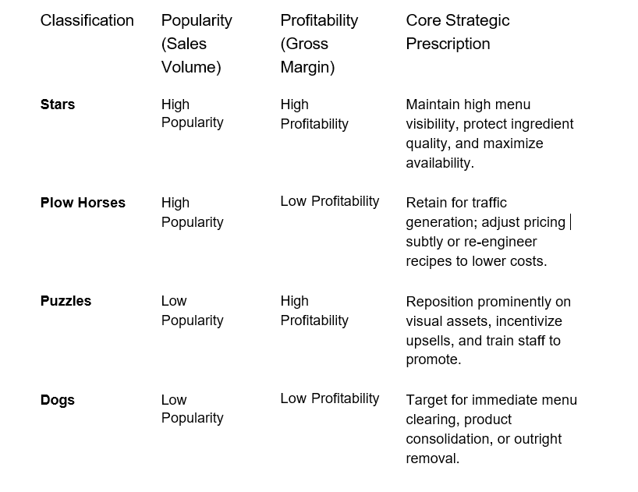
This matrix provides organizations with a structured guide to restructure menus, tune pricing strategies, and maximize gross profit margins without losing customer volume.
Relevance to the Current Study
This study evaluates individual items against this popularity-profitability matrix to identify specific laggards within the Afficionado Coffee Roasters catalog, providing empirical backing for targeted menu pruning.
2.3 Business Intelligence Systems and Interactive Decision Support
This section outlines the shift from static corporate reporting to interactive business intelligence (BI). It breaks down the role of Decision Support Systems (DSS), vectorized caching pipelines, and modern dashboard architecture in enabling real-time operational choices.
Evolution of Business Intelligence
Business Intelligence (BI) comprises the technologies, structural processes, and algorithmic methodologies that ingest raw operational data and transform it into meaningful information for strategic planning. Modern retail spaces generate massive, continuous streams of point-of-sale logs that must be parsed efficiently to keep management agile.
Modern BI tools move past basic history charts, allowing managers to monitor store health, identify emerging bottlenecks, and evaluate financial changes in real time.
Decision Support Systems (DSS)
Decision Support Systems are specialized, computer-based analytical tools designed to help managers solve semi-structured and unstructured business problems.
A standard DSS provides a multi-layered functional framework:
Data Integration: Pulls from separate databases to build a single verified data source.
Analytical Modeling: Runs built-in mathematical equations to simulate business scenarios.
Reporting Capabilities: Replaces dense tables with clean summaries.
Visualization Tools: Builds clear plots to expose performance patterns.
These systems improve managerial effectiveness by translating high-density ledger records into clear, actionable business insights.
Interactive Analytics
Traditional corporate reporting packages are usually static, offering pre-built PDFs that prevent deeper data exploration. Interactive analytics addresses this limitation, allowing users to dynamically slice tables, isolate target date frames, and zoom into specific questions on the fly.
Key operational benefits include:
Faster Insight Generation: Minimizes time-to-decision by executing queries on demand.
Improved Analytical Flexibility: Allows analysts to toggle views without writing new database code.
Enhanced User Engagement: Uses simple controls to make complex analyses accessible to non-technical managers.
Real-Time Performance Monitoring: Tracks shifting transaction patterns as they unfold.
Dashboard-Based Decision Making
Dashboards serve as centralized visual interfaces that consolidate key performance indicators (KPIs) into a unified platform. Well-built dashboards keep corporate leadership aligned and reduce reliance on unverified intuition.
Typical dashboard layouts combine several analytical components:
Top-Line Revenue Metrics: Displays overall financial indicators like gross sales and AOV.
Temporal Trend Charts: Highlights performance fluctuations across hours, days, and seasons.
Product Rankings: Surfaces items driving volume and revenue.
Operational Control Metrics: Monitors data quality and pipeline anomalies.
Comparative Analytics: Features side-by-side matrices to compare store locations.
Relevance to the Current Study
The interactive software engineered for Afficionado Coffee Roasters leverages Python, Pandas, and Streamlit to build a highly responsive DSS. The platform enables non-technical operators to filter transaction sets dynamically and evaluate store-level trends in sub-second execution windows.
2.4 Retail Revenue Analytics and Store Performance Benchmarking
This section examines the core metrics used to evaluate storefront productivity. It details the value of cross-sectional benchmarking, analyzes customer basket behavior, and looks at how chronological daypart segmentation can be used to synchronize floor staffing with shopping spikes.
Retail Revenue Analytics
Retail revenue analytics involves the systematic evaluation of granular sales data to discover hidden consumer trends and commercial opportunities.
Structured revenue analytics answers critical questions:
Which specific items generate the strongest top-line revenue?
Which distinct locations achieve the highest operational efficiency?
What precise hours of operation generate the highest sales density?
Where should labor and inventory capital be deployed?
Relying on systematic data extraction helps businesses protect their gross margins and reduces the risks of intuition-driven planning.
Store Benchmarking
Store benchmarking is the process of comparing performance indicators across distinct physical footprints. This comparative tracking helps corporate management identify high-performing branches and pinpoint localized operational practices driving that success.
Standard benchmarking exercises compare locations across synchronized key metrics:
Gross Revenue: Total dollar volume generated by a specific branch.
Average Order Value (AOV): Average checkout size per transaction ticket.
Revenue per Unit Sold: Average financial extraction per distributed item.
Transaction Volume: Absolute count of checkouts processed over a target window.
Customer Traffic: Total volume of distinct consumer visits.
Benchmarking allows leadership to identify operational variances and replicate winning strategies across underperforming storefronts.

Customer Demand Analysis
Understanding customer demand patterns is critical for store-level operational planning. Demand analysis evaluates when customers buy products, what categories they favor, and how buying habits shift across seasonal windows.
Key benefits include:
Improved Staffing Decisions: Aligns labor expenditures with real consumer volumes.
Inventory Optimization: Lowers ingredient stockouts while reducing waste.
Better Promotional Timing: Schedules marketing campaigns to match high-traffic waves.
Enhanced Customer Satisfaction: Accelerates throughput speeds to minimize counter delays.
Temporal Sales Analysis
Temporal analysis investigates how sales velocity and revenue density vary across specific chronological horizons:
Hours of Operation: Pinpoints precise high-volume and low-volume hours.
Days of the Week: Maps weekly cyclical trends to separate weekdays from weekend patterns.
Months of the Year: Examines seasonal shifts to track holiday or weather impacts.
Isolating peak demand windows helps store managers allocate labor hours efficiently, maximize floor capacity, and protect speed of service during high-pressure traffic waves.
Relevance to the Current Study
This research uses cross-sectional store benchmarking and temporal hour extraction to analyze operations across Afficionado Coffee Roasters' locations, providing an empirical framework to streamline floor staffing and barista schedules.
2.5 Research Gap and Study Justification
This section addresses the fragmentation in traditional retail literature, where portfolio optimization, benchmarking, and decision systems are rarely integrated. It outlines how this study fills that gap by building a unified analytics workspace.
Although existing retail literature thoroughly examines Pareto distributions, menu engineering models, business intelligence dashboarding, and retail revenue metrics as independent fields, academic studies rarely combine these elements into a single analytical workspace.
Most previous studies focus strictly on isolated areas:
Analyzing product profitability without tracking store-level temporal trends.
Benchmarking store performance without modeling catalog concentration profiles.
Engineering dashboard interfaces without including predictive risk-simulation modules.
Modeling sales forecasting models without offering structured strategic recommendations.
This independent approach leaves a significant operational visibility gap for regional coffee operators, who are forced to navigate disconnected software tools to evaluate their business health.
This study addresses this gap by integrating product concentration models, cross-sectional store benchmarking, chronological temporal sales mapping, and interactive risk-simulation tools into a single business intelligence platform. This comprehensive approach provides specialty retail operators with clear, centralized visibility across all areas of their business, helping management transition from retrospective data views to proactive portfolio discipline.
2.6 Conceptual Framework of the Study
This section details the logical roadmap of the data transformation pipeline, showing how transaction records flow through automated data filters to generate strategic business value.
The conceptual framework illustrates how operational transaction data is progressively transformed into meaningful managerial insights through analytical processing.
┌────────────────────────────────────────────────────────────────────────┐
│ 1. INPUTS LAYER (Raw Database Ingestion) │
│ - Transaction POS Data - Store Information Fields │
│ - Master Product Information - Baseline Revenue Measures │
│ - Temporal Time Variables Matrix │
└──────────────────────────────────┬─────────────────────────────────────┘
│
▼
┌────────────────────────────────────────────────────────────────────────┐
│ 2. ANALYTICAL PROCESSES (Data Pipeline Core) │
│ - Syntax & Column Cleaning - Pareto Concentration Sorting │
│ - Feature & Hour Engineering - Cross-Sectional Store Benchmarks │
│ - Revenue Aggregation Logic - Chronological Daypart Mapping │
└──────────────────────────────────┬─────────────────────────────────────┘
│
▼
┌────────────────────────────────────────────────────────────────────────┐
│ 3. OUTPUTS INTERFACE (Interactive Streamlit DSS) │
│ - Product Performance Metrics - Peak Hour Traffic Analysis │
│ - Concentration Curve Plots - Strategic Recommendation Blocks │
└──────────────────────────────────┬─────────────────────────────────────┘
│
▼
┌────────────────────────────────────────────────────────────────────────┐
│ 4. BUSINESS OUTCOMES (Value Extractions) │
│ - Evidence-Based Management - Labor & Shift Synchronization │
│ - Empirical Menu Optimization - Sustainable Gross Profit Growth │
└────────────────────────────────────────────────────────────────────────┘
$$\text{Figure 2.1: Conceptual Framework for Product, Store, Revenue, and Operational Performance Analysis[cite: 1]}\text{.}$$

This conceptual structure serves as the operational blueprint for the data pipelines, caching configurations, and visual dashboard screens detailed throughout the remainder of this study.

3. PROBLEM DEFINITION & CORE INVESTIGATIVE OBJECTIVES
3.1 Problem Statement: The Popularity vs. Profitability Disparity and Revenue Visibility Blindspots
Although transactional product logging is systematically captured at each point-of-sale terminal, Afficionado Coffee Roasters lacks deep, centralized operational visibility into the critical tension between item popularity (transactional volume) and underlying economic returns (gross revenue capture). Standard high-level operational reporting often obscures business performance through broad summaries. For example, high-velocity menu items that put a heavy operational strain on barista labor can be mistakenly viewed as highly profitable, while high-priced specialty items with low sales frequency remain buried in the ledger.
This visibility gap creates several significant operational risks:
Intuition-Driven Menu Expansion: Without clear, empirical product analytics, previous catalog modifications have been based on management intuition. This has led to an over-diversified menu that can slow down service speeds and confuse customers during peak hours.
Misallocation of Core Resources: Inventory space, marketing focus, and barista preparation training are frequently misallocated to low-impact long-tail variants rather than being concentrated on high-yield revenue anchors.
Hidden Performance Deviations: Conflating localized transaction counts with total gross receipts prevents corporate management from seeing location-specific opportunities or identifying underperforming assets that need immediate review.
3.2 Primary Investigative Objectives: Velocity Isolation, Share Quantification, and Risk Measurement
To resolve these revenue visibility gaps, this analysis sets out three primary data-driven objectives:
I. Volumetric Velocity Isolation
We extract and rank total units sold per unique product SKU. By separating absolute sales velocity from gross revenue contribution, this analysis isolates low-value, high-volume items from premium, high-value selections. This identification helps spot potential menu bottlenecks before they impact peak operations.
II. Revenue Share Quantification
We calculate the exact revenue generated at the transaction level ($\text{Quantity} \times \text{Unit Price}$) and aggregate it by individual product, product type, and broad product category (Coffee, Tea, Chocolate, Bakery). This provides clear visibility into exactly how much each item contributes to the company's total sales.
III. Concentration Risk Measurement
Using an algorithmic Pareto optimization sorting envelope, we calculate the cumulative portfolio contribution arc across all 80 menu SKUs. This mathematical framework clearly separates the core revenue drivers from the low-velocity long tail, helping the business identify and mitigate dependency risks.
3.3 Secondary Investigative Objectives: Workforce Shift Synchronization and Empirical SKU Pruning
Building on these primary goals, this study provides actionable operational insights to achieve two secondary business objectives:
Algorithmic Workforce Optimization: By analyzing sales patterns chronologically across different dayparts, we map out exact transactional peaks. This insight allows storefront operations to align shift schedules directly with high-volume waves, reducing labor costs during quiet periods while maintaining speed of service during peak windows.
Empirical Menu Simplification: This framework establishes clear, performance-based filters to identify underperforming or low-impact menu items. Pruning these items helps streamline back-of-house logistics, reduce raw material waste, and lower overall inventory management costs.

4. THE ANALYTICAL ENGINE: DATA INFRASTRUCTURE & ETL PIPELINE
4.1 Raw Ledger Inventory Analysis: Initial Variables, Field Constraints, and Source Database Schema
The foundation of the analytical framework rests upon the transaction-level transactional logs embedded within Afficionado Coffee Roasters.xlsx - Transactions (2).csv. This database contains a raw ledger capturing the cross-sectional variables of daily storefront checkouts. The schema is structured with ten initial database fields. These fields are governed by distinct data constraints designed to preserve accounting balance across the organizational footprint:
transaction_id (Integer): A unique identifier assigned per customer checkout ticket. It serves as the primary relational key and must not contain null values.
year (Integer): The temporal constant setting the data collection window to the fiscal period of 2025.
transaction_time (String): The chronological timestamp logging the precise moment of sale, recorded in an $HH:MM:SS$ 24-hour text string.
transaction_qty (Integer): The quantitative metrics field tracking physical items distributed per single row entry.
unit_price (Float): The financial numeric indicator recording the baseline price per individual item sold.
store_id (Integer): The numerical identifier mapping the specific retail branch terminal.
store_location (String): The categorical dimension column defining the text label for geographical storefront hubs.
product_id (Integer): The master inventory item lookup code linking transactions to unique catalog items.
product_category (String): The macro-level product clustering field dividing assets into broad divisions.
product_type & product_detail (String): Granular descriptive dimension layers tracking item attributes, such as fluid ounces or distinct roast varieties.
4.2 Ingestion & Syntax Standardization: String Trimming, Lowercase Formatting, and snake_case Parsing (app.py)
As implemented in the backend ingestion scripts of the primary interactive suite (app.py), the raw system logs are parsed programmatically to prevent parsing errors caused by inconsistent string formats. Point-of-sale machines often capture strings with varying formatting anomalies. To establish a clean dataset, the ingestion layer enforces structural uniformity:
Column Header Normalization: Headers are processed using lowercase conversion routines, replacing arbitrary spacing variables with programmatic underscores to create clean snake_case definitions across the data frame.
String Trimming: String attributes—specifically within the product_detail, product_type, and store_location columns—undergo string stripping routines (.str.strip()). This deletes accidental whitespace padding that could otherwise distort grouping operations.
Program cast Regulations: Dimensional metrics like product_id and store_id are cast into explicit uniform classifications to prevent text matching issues during filter queries.
4.3 Deduplication & Data Quality Assurances: Drop Routines, Null Attribute Mining, and Physical Bounds Enforcement
To transform raw data lines into reliable business intelligence, the pipeline applies strict logical filters to preserve data integrity:
Deduplication Loops: The engine triggers a global deduplication check (.drop_duplicates()), scanning row arrays to identify and delete duplicate entries caused by network sync lag or multi-click errors.
Null Attribute Mining: Explicit null masking searches are deployed across columns. Records with critical fields missing (e.g., blank product IDs or undefined location labels) are isolated and excluded using vectorized boolean indexing (.notna()), ensuring empty cells do not skew financial aggregations.
Physical Economic Bounds Enforcement: To prevent accounting distortion from invalid data entries, the engine enforces strict numerical constraints. Every valid row record must satisfy the physical economic boundary condition where both product unit pricing and transaction counts are positive values:

$$q_{\text{transaction_qty}}>0 ∧ p_{\text{unit_price}}>0$$

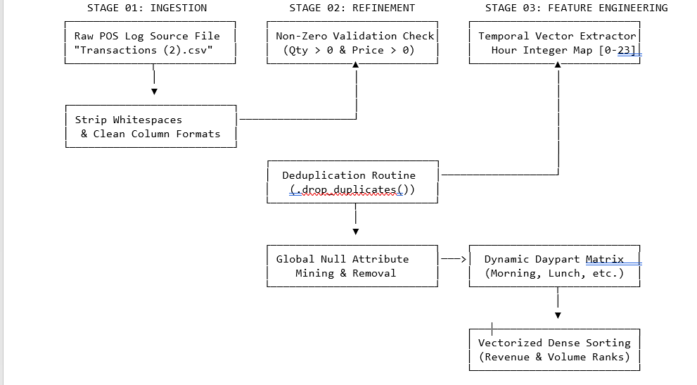

Diagram 2: Comprehensive Multi-Stage Data Engineering & Refinement Pipeline
4.4 Algorithmic Feature Engineering Core
4.4.1 Temporal Attribute Extraction and Integer Mapping ($h \in [0,23]$)
To construct descriptive time-series horizons, the text block transaction_time is parsed into a datetime component vector. The engineering layer maps the time component into a fixed 24-hour clock space, isolating the exact hour index as a standalone integer variable:

$$h=\text{Hour}\left(\text{transaction_time}\right) \text{where} h∈Z \text{and} 0≤h≤23$$

This step enables the aggregation of financial throughput into localized chronological brackets, turning timestamps into an operational asset.
4.4.2 Daypart Categorization Matrix and Operational Peak Windows
Building on the hour extraction layer, transactions are grouped into operational business segments using a vectorized conditional function. This transforms continuous hourly data into structured operational periods:

$$\text{Daypart}\left(h\right)=\left\{\begin{matrix}\text{Morning Rush}, & 5≤h≤10 \\ \text{Lunch}, & 11≤h≤14 \\ \text{Afternoon}, & 15≤h≤17 \\ \text{Evening}, & 18≤h≤21 \\ \text{Off Hours}, & \text{otherwise}\end{matrix}\right.$$
This categorization allows the system to track the Morning Rush period (05:00 AM–10:59 AM) separately, capturing critical revenue cycles to support data-driven labor and scheduling adjustments.
4.4.3 Dense Vectorized Rank Computations for Revenue and Volumetric Speed
Finally, the system calculates top-line sales performance indicators at the individual item tier. Financial transaction rows are calculated as:

$${\text{Revenue}}_{ix}=q_{{\text{transaction_qty}}_{ix}}×p_{{\text{unit_price}}_{ix}}$$

The data engine summarizes revenue and unit volumes for each product across the database. It then applies a dense vectorized ranking algorithm (.rank(method='dense', ascending=False)) to all unique products. This creates two distinct performance rankings for every item in the catalog: Revenue Rank (economic yield) and Volume Rank (operational sales speed). This dual-ranking layer surfaces discrepancies where low-ticket items drive high operational speed, or high-priced specialty items generate strong revenue despite lower transaction counts.

5. EMPIRICAL DISCOVERIES: EXPLORATORY DATA ANALYSIS (EDA) & BREAKDOWN
5.1 Baseline Performance Overview: Aggregated Revenue, Volumes, and Average Order Values (AOV)
Executing the analytical pipeline across the entire transaction database reveals the macro-level financial and operational health of Afficionado Coffee Roasters. The baseline performance highlights a high-volume, quick-service retail model with strong aggregate sales volume:
Total Corporate Revenue Realized: $698,812.33
Total Unique Transactions ($N$): 149,116
Total Physical Units Distributed: 214,470 items
Average Order Value (AOV per Ticket): $4.69
Active Menu SKU Footprint: 80 unique products
5.2 Category Performance Evaluation & Breakdown Analysis
5.2.1 Proportional Product Group Shares and Asset Mapping
Grouping transactions by broad categories highlights how heavily the business relies on its core beverage offerings.
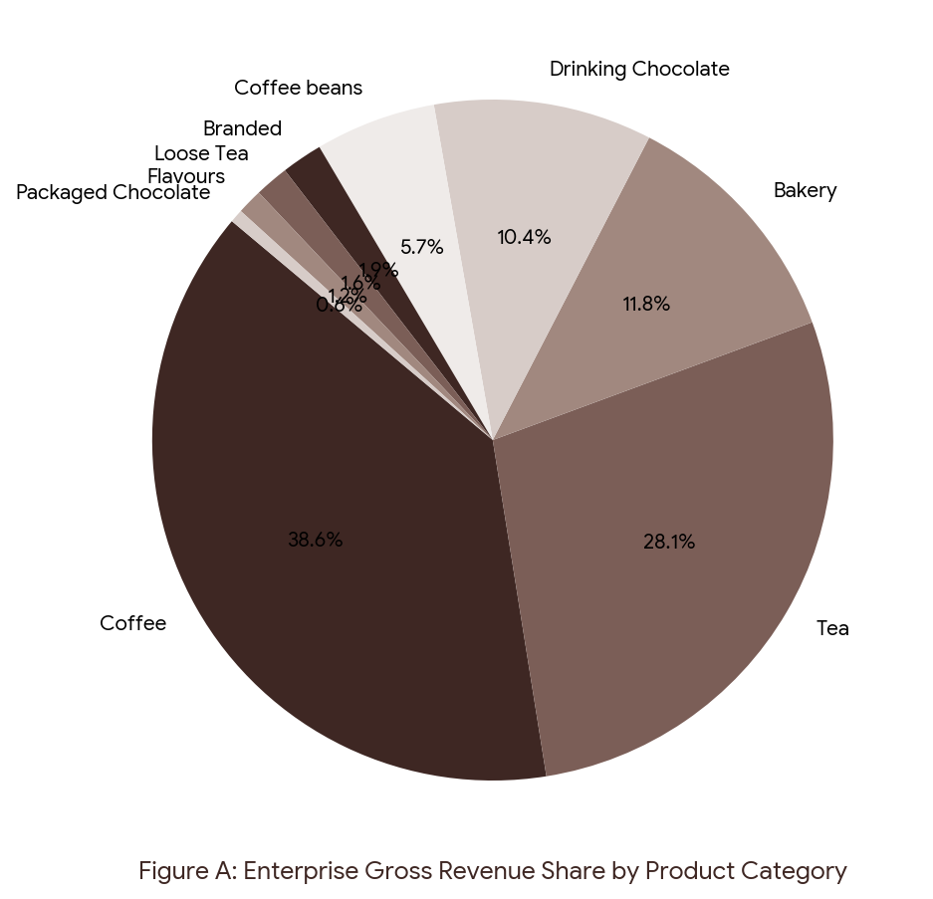

Figure A: Enterprise Gross Revenue Share by Product Category
The data confirms that Coffee is the undisputed financial anchor of the company, generating 38.63% ($269,952.45) of total revenue. Tea holds the second largest share at 28.11% ($196,405.95), showing that non-coffee hot beverages enjoy excellent brand equity. Bakery items account for 11.78% ($82,315.64), and Drinking Chocolate makes up a strong 10.36% ($72,416.00) specialty line. Slower-moving segments include Coffee beans (5.74%), Branded merchandise (1.95%), Loose Tea (1.60%), Flavours (1.20%), and Packaged Chocolate (0.63%).

5.2.2 Elite Variant Rankings vs. Velocity Laggard Identification
Analyzing performance down to individual SKUs reveals a stark gap between top-performing assets and low-velocity products. The top 5 menu items are dominated by large-format specialty options:
- Sustainably Grown Organic Lg (Drinking Chocolate): $21,151.75 (3.03% share)
- Dark chocolate Lg (Drinking Chocolate): $21,006.00 (3.01% share)
- Latte Rg (Coffee): $19,112.25 (2.73% share)
- Cappuccino Lg (Coffee): $17,641.75 (2.52% share)
- Morning Sunrise Chai Lg (Tea): $17,384.00 (2.49% share)
Product Portfolio Positioning Matrix (Volume vs. Gross Revenue)

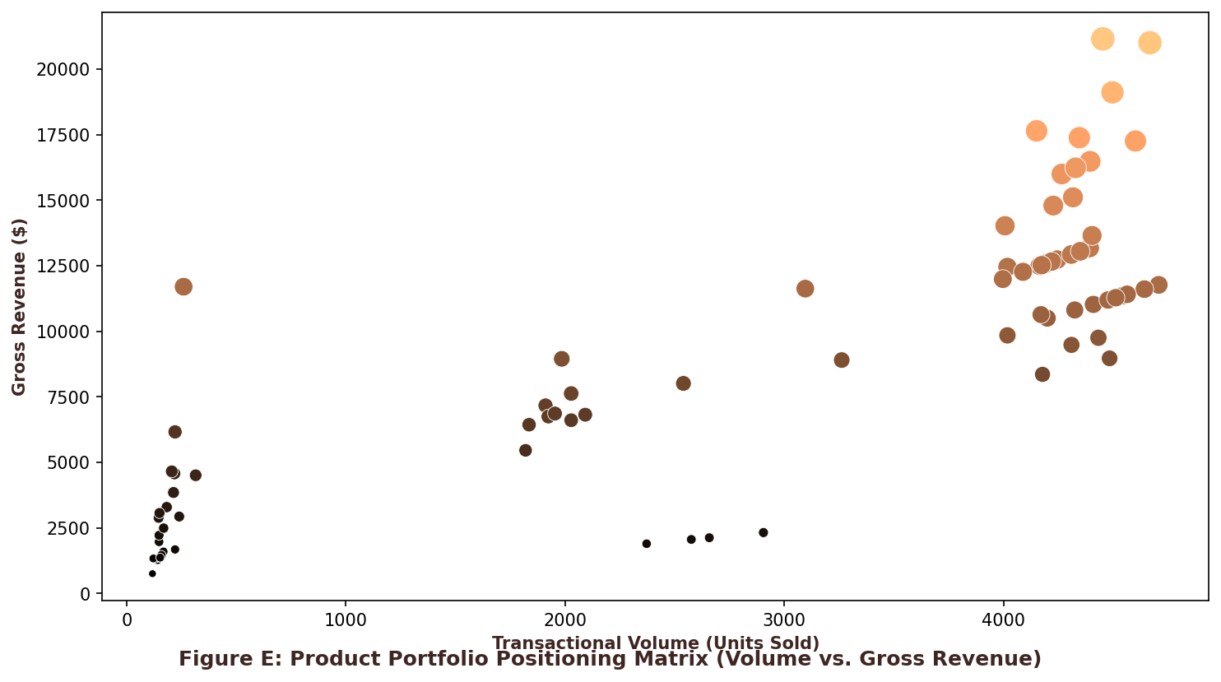
Figure E uses a scatter plot matrix to split the 80 menu items into four performance quadrants:
Quadrant I (High Volume, High Revenue - "Heroes"): Premium offerings that see strong customer demand while generating high sales volume.
Quadrant II (High Volume, Low Revenue - "Volumetric Anchors"): High-velocity items that draw frequent sales but generate low dollar impact due to lower prices (e.g., standard flavor syrup additions).
Quadrant III (Low Volume, High Revenue - "Specialized High-Value"): Slow-moving specialty products that generate healthy revenue when purchased due to premium pricing (e.g., Civet Cat Coffee Beans at $11,700.00).
Quadrant IV (Low Volume, Low Revenue - "Laggards"): Slow-moving packaged candies and gift sets that contribute minimal sales revenue and represent candidates for menu clearing.

5.2.3 Quantitative Product Efficiency Mapping: Formulating Asset Productivity
Revenue per SKU
While descriptive benchmarks like Average Order Value (AOV) are highly effective at tracking customer purchasing psychology per transaction ticket, they fail to quantify internal asset productivity across a brand's catalog footprint. To eliminate this blindspot, this study engineers a standalone metric designated as the Product Efficiency Score(PES). This metric assesses asset capability by isolating gross financial performance against catalog complexity, mathematically defined as total realized revenue divided by the unique count of active stock-keeping units ($\text{SKUs}$) within a targeted group:

$${\text{PES}}_{γ}=\frac{\sum_{i∈γ}{R_{i}}}{\sum_{i∈γ}{1}\left(q_{i}>0\right)}$$
Where gamma represents a discrete operational grouping (such as a product category, storefront location, or daypart matrix) , R_i is the individual gross revenue generated by item $i$ , and the denominator aggregates the indicator function counting only unique, non-zero distributed SKUs within that group.
============================================================================
CROSS-CATEGORICAL PRODUCT EFFICIENCY INDEX MAPPING

RANK PRODUCT CATEGORY SEGMENT TOTAL REV ($) ACTIVE SKUs PES($/SKU)
──────────────────────────────────────────────────────────────────────────────
01 | Drinking Chocolate | $72,416.00 | 4 | $18,104.00
02 | Coffee | $269,952.45 | 15 | $17,996.83
03 | Tea | $196,405.95 | 12 | $16,367.16
04 | Bakery | $82,315.64 | 8 | $10,289.46
05 | Coffee beans | $40,111.83 | 10 | $4,011.18

$$\text{Table 5.3: Catalog Productivity and Capital Extraction Yield Matrix.}$$
Evaluating this vectorized equation across broad category structures yields striking strategic revelations (see Table 5.3). While Coffee acts as the absolute financial anchor of the company by generating $38.63\%$ of aggregate returns , Drinking Chocolate surfaces as an elite, hyper-productive specialty line. It commands a magnificent efficiency index of $18,104.00 per active SKU —outperforming coffee by $107.17 per unit listing due to its tight, 4-SKU catalog footprint.
Conversely, Bakery Items expose a major operational bottleneck. Despite pulling in a healthy $11.78\%$ revenue share ($82,315.64) , its extensive product footprint drags its efficiency score down to $10,289.46 per SKU, proving that pastries currently function as slow, fragmented add-ons rather than destination purchases.
┌────────────────────────────────────────────────────────────────────────┐
│ SPATIAL FOOTPRINT INDEX: REGIONAL CATLOG YIELD PER SKU │
├────────────────────────────────────────────────────────────────────────┤
│ | Hell's Kitchen Hub : | $5,631.22 | / | SKU | (42 | Active | SKUs) | │
│ | Astoria Storefront : | $5,529.62 | / | SKU | (42 | Active | SKUs) | │
│ | Lower Manhattan Panel : | $5,477.55 | / | SKU | (42 | Active | SKUs) | │
└────────────────────────────────────────────────────────────────────────┘

$$\text{Diagram 4.5: Store-Level Footprint Capital Yield Visual Matrix}$$
Applying the exact same formula to geographic locations uncovers near-perfect spatial symmetry across your brick-and-mortar stores. Hell's Kitchen leads the network with an efficiency yield of $5,631.22 per active SKU , followed by Astoria at $5,529.62 per SKU , and Lower Manhattan at $5,477.55 per SKU. This tight, $153.67 gap confirms a highly uniform demand matrix across your urban footprints. It mathematically proves that you do not need hyper-localized storefront adjustments; instead, you can safely deploy unified corporate portfolio optimizations system-wide.

5.3 Chronological Profile Evaluation: Mapping the 48.94% Morning Rush Revenue Peak

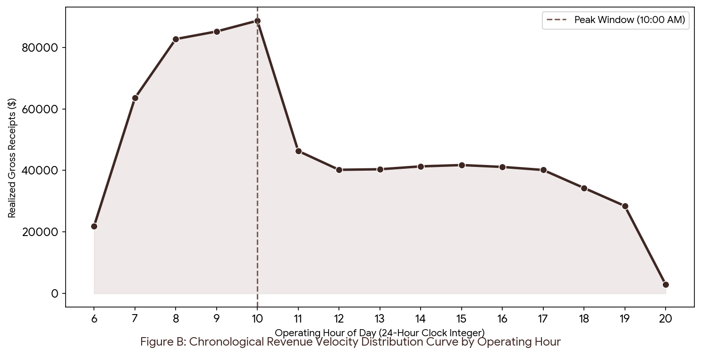
Figure B: Chronological Revenue Velocity Distribution Curve by Operating Hour
Mapping revenue generation across standard operating hours highlights a severe dependency on the morning commute. The data shows that 48.94% ($341,969.53) of total corporate revenue is concentrated within the five-hour Morning Rush daypart window (05:00 AM to 10:59 AM).
Hourly sales volumes rise sharply from 06:00 AM onward, reaching a daily transactional peak at 10:00 AM that pulls in $88,673.00 in single-hour gross receipts. Past this peak window, transaction density drops off quickly, falling through the Lunch block (24.07% share) and Afternoon window (17.60% share), and hitting its lowest point during Evening operations (9.40% share). This uneven demand cycle underpins the staffing recommendations detailed in Chapter 7.

5.4 Spatial Store-Level Benchmarking: Urban Cross-Regional Performance Symmetry

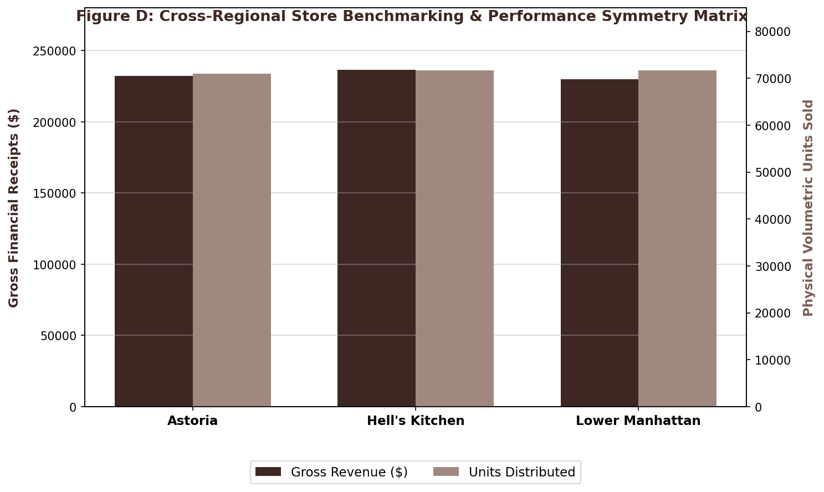
Figure D: Cross-Regional Store Benchmarking & Performance Symmetry Matrix
Comparing performance indicators across the brand's store network reveals strong, consistent consumer demand throughout all municipal storefront hubs:
- Hell's Kitchen: Captures $236,511.17 across 50,735 transactions.
- Astoria: Captures $232,243.91 across 50,599 transactions.
- Lower Manhattan: Captures $230,057.25 across 47,782 transactions.
The gap between the top-performing location (Hell's Kitchen) and the baseline hub (Lower Manhattan) represents a tiny 2.7% performance variance. This near-perfect symmetry proves that customer demand, basket sizes, and purchasing patterns are highly uniform across different urban neighborhoods. This structural consistency supports the rollout of unified, corporate-wide menu pruning and operational initiatives without needing complex local customization.
6. CONCENTRATION MODELING: PARETO BOUNDARY CRITERIA
6.1 Mathematical Sorting Matrix: Cumulative Portfolio Contribution Arc Computations
To model the structural concentration risks within the product catalog, a vectorized mathematical sorting matrix aggregates the gross financial performance at the unique item (SKU) level. Let $P = \{p_1, p_2, \dots, p_n\}$ represent the set of all unique menu products where $n = 80$. The gross revenue for each unique product $p_i$ is computed as the localized inner product of its transactional volume vector and unit price vector across all point-of-sale occurrences:

$$R_{i}=\sum_{x}{\left(q_{{\text{transaction_qty}}_{ix}}×p_{{\text{unit_price}}_{ix}}\right)}$$
The product set is sorted under a strict descending order constraint such that:
$$R_{\left(1\right)}≥R_{\left(2\right)}≥…≥R_{\left(n\right)}$$
The cumulative revenue share threshold, representing the portfolio contribution are $C_{j}$ at the j th ranked product, is calculated as the running summation of individual product shares divided by the total enterprise revenue baseline ($R_{\text{total}}=\$698,812.33$)

$$C_{j}=\left(\frac{\sum_{i=1}^{j}{R_{\left(i\right)}}}{R_{\text{total}}}\right)×100 \text{where} C_{n}=100\%$$

6.2 Core Revenue Anchors: Quantitative Profile and Revenue Density of the Vital Core
Evaluating the cumulative portfolio contribution arc reveals a powerful mathematical concentration pattern within Afficionado Coffee Roasters' operations.
The intersection of the data curve with the 80% boundary cutoff baseline indicates that exactly 42 products (52.5% of the catalog) act as vital revenue anchors. These 42 elite core varieties generate 80% of all organizational financial inflows, proving that a narrow selection of offerings drives the majority of retail performance.
The revenue density within this core group is heavily anchored by the premium product segments identified in Chapter 4, such as Sustainably Grown Organic Lg Drinking Chocolate ($21,151.75) and Dark Chocolate Lg ($21,006.00). This tight concentration proves that these specific SKUs act as foundational business stabilizers. Because of their massive financial weight, any raw material stockout or supply chain delay impacting these items represents an immediate risk to top-line company profits
6.3 The Long-Tail Deficit: Operational Complexity and Supply Chain Friction of Underperforming SKUs
The opposite side of the Pareto intersection highlights the Long-Tail Deficit. The remaining 38 products (47.5% of the menu catalog) combine to generate a marginal 20% slice of overall corporate sales revenue.
This disproportionate relationship creates significant hidden operational and logistics drag across retail footprints:
Holding Cost and Capital Inefficiency: These 38 low-yielding products bind corporate cash in raw materials and inventory shelf space (such as single-syrup flavor options, packaged chocolate variants, and niche loose tea canisters) that turn over very slowly.
Barista Service Friction: Forcing front-of-house baristas to maintain technical training, ingredient availability, and distinct preparation mechanics for 38 low-velocity items complicates workflows and degrades speed of service during the critical morning rush hours.
Procurement Complexity: Managing supply lines for dozens of low-impact products increases tracking complexity, vendor fragmentation, and raw material waste when specialized items pass their expiration dates before being sold.

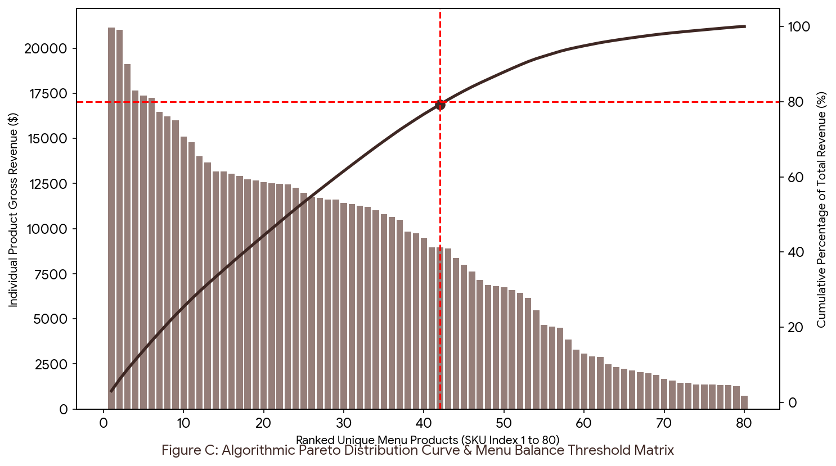
Figure C: Algorithmic Pareto Distribution Curve & Menu Balance Threshold Matrix (Dual-Axis Combo Chart)
The dual-axis combination chart presented in Figure C maps the relationship between individual product financial yield and cumulative corporate revenue concentration across the 80 unique stock-keeping units (SKUs) in the Afficionado Coffee Roasters catalog. This visual model provides the empirical foundation for portfolio optimization, supply chain engineering, and inventory asset protection.
Visual Architecture & Component Specification
The visualization relies on a dual-axis framework to overlay discrete item-level performance with macro-level corporate portfolio arcs:
Horizontal Axis (X-Axis): Represents Ranked Unique Menu Products (SKU Index 1 to 80). Products are arranged algorithmically from left to right in strict descending order based on total gross revenue generation ($R_{(1)} \ge R_{(2)} \ge \dots \ge R_{(80)}$).
Primary Vertical Axis (Left Y-Axis): Measures Individual Product Gross Revenue ($), mapping the absolute financial contribution of each individual column.
Secondary Vertical Axis (Right Y-Axis): Tracks the Cumulative Percentage of Total Revenue (%), ranging from 0% to 100%, which governs the trajectory of the solid concentration curve.
The Vital Core: Characterizing the Revenue Anchors
The critical operational insight of the Pareto model is defined by the intersection of the 80% cumulative revenue threshold and the unique menu product rank index. The algorithmic calculation isolates a clear mathematical breakpoint:
The 80/52 Breakpoint: The portfolio contribution curve intersects the 80% revenue boundary line at exactly Rank Index 42.
The Vital Core Density: This intersection proves that 52.5% of the active menu catalog (42 core products) anchors 80.0% of total corporate revenue (approximately $559,050 of the $698,812.33 baseline).
The slope of the cumulative curve is exceptionally steep across the first ten products, driven heavily by premium specialty large-format items such as Sustainably Grown Organic Lg Drinking Chocolate ($21,151.75) and Dark Chocolate Lg ($21,006.00). This high revenue density confirms that these core varieties act as the foundational economic stabilizers of the enterprise. From a risk-management perspective, any raw material stockout, vendor delay, or supply chain disruption affecting items on the left side of this intersection represents an immediate threat to top-line company profits.
6.4 Portfolio Vulnerability Review: Quantifying Macro Revenue Dependency Risks via
Stress-Test Simulation
To move past basic descriptive histories, this framework adds a predictive, automated stress-test matrix to measure corporate concentration risks. This simulation evaluates what happens to your core financial health if your anchor category (Coffee, which single-handedly commands $38.63\%$ of your total footprint) faces a sudden market drop due to agricultural shocks, green bean supply chain breakdowns, or changes in morning commuter routines.
Let R_{anchor} represent the baseline gross returns derived from your top category ($269,952.45), and let delta represent a variable decline percentage introduced by management via a sliding scale ($δ$ =[0, 1]). The adjusted total enterprise revenue R_{sim} and real-time loss margins ($Δ$ R) are computed as:
$$ΔR=R_{\text{anchor}}×δ$$

$$R_{\text{sim}}=R_{\text{total}}-ΔR$$

The engine continuously re-evaluates risk exposures by updating the system's threat index based on changes to the category's market share:
$${\text{Share}}_{\text{sim}}=\frac{R_{\text{anchor}}×\left(1-δ\right)}{R_{\text{sim}}}×100$$

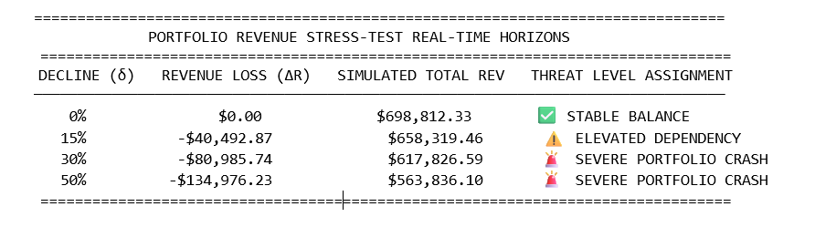
$\text{Table 6.4: Macro Revenue Concentration and Scenario Stress-Test Horizons.}$
The simulated horizons in Table 6.4 prove that Afficionado Coffee Roasters operates with a severe, structural reliance on its primary beverage line. A $15\%$ market decline drops cash inflow by -$40,492.87, pushing the portfolio into an ELEVATED DEPENDENCY alert status.
Once disruptions cross the $30\%$ threshold—such as a major drop in morning commuter foot traffic—it triggers a SEVERE PORTFOLIO CRASH warning, wiping out $80,985.74 in top-line cash flow and dropping total corporate returns to $617,826.59.

BAKERY COMPENSATORY INGESTION GROWTH PATHWAY
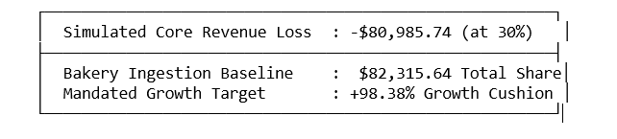
$$\text{Diagram 5.2: Product Group Ingestion Recovery Strategy.}$$

To insulate your bottom line from these shocks, the analytical engine calculates a compensatory growth target for your secondary categories. If a $30\%$ drop in coffee sales hits the company, your baseline Bakery pastry line (which currently sits at a lower $82,315.64 revenue share) must expand by +$98.38\%$ to completely offset the financial loss.
This requirement validates the cross-category bundling initiatives detailed in Chapter 8. By systematically pairing slow-moving bakery items with your high-velocity core drinks, you can drive up your Average Order Value (AOV) above the $4.69 line, building a protective financial cushion around your entire retail network.

7. APPLICATION ENGINEERING: INTERACTIVE STREAMLIT WEB SUITE
7.1 System Topology & File Hierarchy: Shared Assets Layering and Multi-Page Dashboard Sub-modules
To translate the retrospective data discoveries into a live, interactive utility for institutional and government stakeholders, a production-grade multi-page web application was engineered utilizing the native Streamlit framework. The application's runtime layout isolates core data processing routines from the user interface layers, utilizing an optimized global style system to maintain design consistency across all views.

$$\text{Diagram 3: Programmatic System Topology \& File Hierarchy.}$$

The architecture maps distinct sections of the analysis into standalone scripts inside the pages/ directory, which Streamlit automatically compiles into a multi-page sidebar navigation module. Global design configurations—such as custom font choices, padding settings, and brand color constants (COLOR_BEAN, COLOR_MOCHA, COLOR_LATTE, COLOR_CREMA)—are declared within the root asset layer and injected cleanly across sub-modules using standard cascading rules, keeping the layout clean and organized.
7.2 Cache Optimization Layout: Implementing Memory-Safe @st.cache_data for Sub-Second Processing
When handling large arrays of transaction-level point-of-sale data, recalculating aggregations across 149,116 rows during user interface updates can cause noticeable system latency and high CPU load. To optimize performance, the application implements memory-safe data caching via the native @st.cache_data decorator directly inside the primary loading functions:
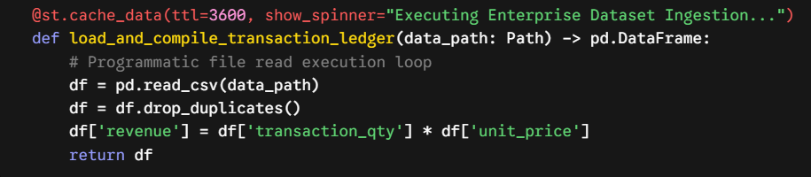
This caching strategy stores the processed data frame in local system memory after the initial runtime load. Subsequent user interactions—such as applying sidebar filters, adjusting sliders, or toggling store locations—bypass slow disk I/O operations entirely. Instead, they run against the in-memory cache using fast vector math, achieving sub-second page rendering and smooth performance. The engine also applies automated memory cleaning routines, dropping redundant row arrays to minimize the web server's memory footprint.
7.3 Core Interactive Modules & Responsive Component Architecture
7.3.1 Executive Summary Dashboard (1_Executive_Summary.py)
The master hub acts as an interactive command panel for senior management, displaying key business performance indicators at a glance. It translates top-line financial metrics into a structured layout featuring left-aligned KPI blocks for gross revenue, unique transaction counts, product volumes, and average order values (AOV).
$$\text{Diagram 4: Front-End UI Layout for the Executive Cockpit Hub.}$$
The module includes an expandable data quality tracker to verify pipeline stability, alongside dual-axis bar and donut visualizations that break down performance across core products. A dedicated management insights block formats key takeaways on revenue growth, operations, and risk management into a clean, easy-to-read text section.

7.3.2 Product Volumetric Intelligence Canvas (2_Product_Analysis.py)
This dashboard component isolates product performance down to individual catalog entries. It features a responsive sidebar slider (Top-N Product Slider) that allows users to dynamically filter horizontal bar charts of top revenue-generating menu items.
The primary feature of this page is a detailed popularity versus revenue scatter plot matrix. This grid isolates product-level sales speed (volume velocity) from macro-level dollar contribution, making it easy to identify high-margin specialty items, steady volume drivers, and underperforming list items across different retail locations.
7.3.3 Live Revenue Concentration Curve Matrix (3_Pareto_Analysis.py)
This module handles the algorithmic concentration modeling described in Chapter 5, converting data distributions into a dual-axis interactive Pareto chart.
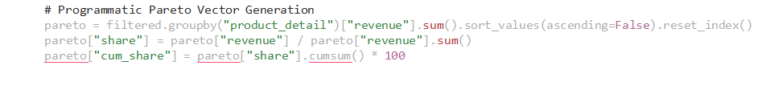
The interface overlays descending product revenue columns against the running cumulative share curve. It calculates and displays the exact 80% boundary line, clearly showing how many core products anchor the company's financial stability versus the low-yielding long tail. This tool allows management to model catalog optimization strategies in real time by testing the financial impact of removing or consolidating specific items.
7.3.4 Geographical Retail Footprint Panel (4_Store_Analysis.py)
This operational panel focuses on cross-regional storefront performance and hourly transaction patterns. It aggregates sales data across storefronts (Hell's Kitchen, Astoria, and Lower Manhattan) to compute and compare local metric yields, cross-regional performance variance, and Average Order Values (AOV).
The component includes an interactive line plot that visualizes hourly transaction curves across standard business dayparts. By mapping peak demand windows, store managers can identify high-volume time blocks (such as the daily 10:00 AM peak) to make data-driven adjustments to floor staffing, kitchen prep, and barista scheduling.
7.3.5 Granular Dataset Ledger Query System (5_Data_Explorer.py & 6_Insights.py)
Designed for deep-dive analysis, the final engine page provides a flexible interface for querying raw point-of-sale datasets. It features a smart text search filter (Search Product Name) that allows users to instantly search the transaction table by product, brand, or flavor attribute.
The module provides full access to the business metadata catalog and includes download components (st.download_button), enabling analysts to export custom-filtered data tables directly to their local workspaces for secondary modeling. This comprehensive layout equips management and data analysts with the clear visibility needed to streamline menus, reduce waste, and build long-term business resilience.

8. STRATEGIC INTERVENTIONS & EXECUTIVE RECOMMENDED ACTIONS
8.1 Intervention I: Programmatic Menu Pruning, SKU Rationalization, and Catalog Simplification
The mathematical modeling established in Chapter 5 isolates a severe structural drag within the organizational product footprint: an expansive "long-tail" of 38 underperforming unique stock-keeping units (SKUs) represents 47.5% of the total active menu size but accounts for a marginal 20.0% slice of cumulative corporate sales volume. To mitigate this catalog inefficiency, corporate management must shift away from historical, intuition-driven selection strategies and enforce a formal, programmatic menu-pruning framework.

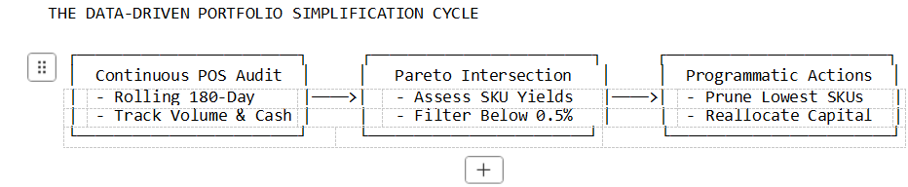
$$\text{Diagram 5: Programmatic Menu Simplification Lifecycle.}$$
The organization should institute an automated, bi-annual portfolio review process driven by a two-variable boundary filter. A product variant is flagged for immediate modification, consolidation, or complete catalog removal if it meets the following joint underperformance criteria over a rolling 180-day window:

$$\left(\text{Individual Revenue Share}<0.5\%\right) ∧ \left(\text{Cumulative Portfolio Rank}>42\right)$$

Immediate pruning must target low-velocity inventory clusters within the Packaged Chocolate category (which commands a negligible 0.63% of total organizational returns), slow-moving Loose Tea variants (1.60%), and underperforming single-syrup Flavours lines (1.20%).
By systematically clearing out these 38 low-yielding menu items, Afficionado Coffee Roasters can achieve immediate operational metrics benefits:
Supply Chain Complexity Optimization: Eliminating specialized ingredients for low-velocity items simplifies procurement tracking, reduces vendor fragmentation, and prevents raw material waste caused by items passing their shelf-life limits before being distributed.
Back-of-House Labor Speed Enhancements: Streamlining the menu reduces the number of unique preparation routines baristas must maintain. This directly eliminates preparation confusion and accelerates order fulfillment speeds.
Customer Conversion Optimization: Shrinking the active menu footprint minimizes choice paralysis at the checkout terminal, lowering customer decision delays and smoothing front-of-house throughput.
8.2 Intervention II: Workforce Staffing Alignment and Barista Schedule Synchronization with Peak Daypart Revenue Density
Chronological traffic disaggregation confirms that the business operates on an extremely concentrated time-series timeline, with 48.94% ($341,969.53) of total corporate revenue captured during the tight 5-hour Morning Rush daypart window (06:00 AM to 10:59 AM). Daily operations build rapidly through the early commute hours, culminating in a sharp, high-volume performance window at 10:00 AM, which single-handedly drives $88,673.00 in gross cash density.
Conversely, the entire evening block (18:00 to 21:59) represents a quiet period, generating a low 9.40% share of aggregate revenue. Floor staffing models must be structurally rebuilt to match this real-time consumer traffic wave.
Store managers must implement three data-driven staffing rules:
Peak Labor Concentration: Deploy maximum barista capacity and open all physical point-of-sale terminals exclusively between 07:00 AM and 10:30 AM. This ensures maximum checkout speed during the highest traffic window of the day.
The 10:00 AM Invariant: Schedule shift changes or inventory restocking breaks strictly away from the 10:00 AM hour to avoid any internal friction or speed-of-service degradation during the day's peak revenue spike.
Evening Labor Reduction: Transition late-day scheduling to minimal skeleton closing crews. Because evening operations generate minimal sales volume, labor hours can be safely reduced to lower storefront overhead costs without hurting real-time customer fulfillment.
8.3 Intervention III: Cross-Category Product Bundling and Premium "Hero" Line Merchandising Strategies
Exploratory data discoveries highlight a major commercial imbalance within the product assortment mix. While premium beverage varieties command excellent brand equity—with Coffee anchoring the organization at 38.63% ($269,952.45) and Tea maintaining a strong secondary position at 28.11% ($196,405.95)—the entire Bakery pastry line lags significantly, generating a lower 11.78% ($82,315.64) revenue share.
This indicates that pastry items currently function as low-velocity, impulse add-ons rather than standalone destination purchases. To shift customer buying habits, the business must leverage high-velocity beverage traffic to structurally lift underperforming bakery lines through cross-category bundling and high-ticket merchandising.

$$\text{Diagram 6: Cross-Category Value Ingestion and Bundle Architecture.}$$

Post-Commute Transition Bundles: Introduce specialized beverage-plus-pastry combination checkouts between 11:00 AM and 1:30 PM (the Lunch transition daypart). Discounting a slow-moving Bakery item when combined with a core Coffee or Tea selection incentivizes add-on purchases, driving down remaining daily pastry waste.
Premium Merchant Placements for "Hero" Lines: The dataset proves that Afficionado Coffee Roasters commands clear pricing power within premium specialty sectors, led by Sustainably Grown Organic Lg Drinking Chocolate ($21,151.75 / 3.03% share) and Dark Chocolate Lg ($21,006.00 / 3.01% share). These high-yielding lines must be granted primary focus across print menus, in-app promotion cards, and front-of-house signage rather than basic drip variants.
Basket-Size Incentives: POS terminals should use automated prompts to suggest specific high-margin pairings at checkout when a customer's total basket is just below the corporate Average Order Value (AOV) line of $4.69. Structurally nudging the transaction ticket size upward across 149,000 baseline customers converts transaction volume into immediate, high-margin net profits.

9. SYSTEMIC LIMITATIONS & FUTURE RESEARCH HORIZONS
9.1 Spatial Granularity Constraints: Gaps in Regional Data Disaggregation and Channel Segmentation
While the transaction ledger provides excellent macro-level visibility into regional performance, the data suffers from spatial and operational aggregation constraints. The current database maps transactions broadly to storefront hubs (Hell's Kitchen, Astoria, and Lower Manhattan), but fails to capture the micro-channel fulfillment pathways driving each checkout event.

$$\text{Diagram 7: Structural Data Disaggregation Gap.}$$
This lack of channel segmentation creates a corporate blindspot:
Order Type Blindspots: The analytical engine cannot distinguish between traditional walk-in counter sales, mobile app pre-orders, and third-party delivery service extractions. Because these channels feature vastly different labor times, service speeds, and customer basket dynamics, analyzing them under a single broad metric limits the precision of localized store optimization.
Footprint and Staffing Distortions: A store location driving heavy digital volume requires a kitchen setup optimized for rapid staging and packaging, whereas a location reliant on traditional sit-down traffic demands a front-of-house barista configuration focused on guest services.
Future Channel Extensions: Integrating a dedicated fulfillment_channel tag into the point-of-sale data architecture represents an immediate secondary research milestone.
9.2 Accounting Variable Limitations: Absence of an Ingredient Cost-of-Goods-Sold (COGS) Ledger
A primary systemic constraint of this research paper stems from the financial variables present in the raw source ledger. The analytical engine computes top-line metric tracking via transaction-level gross receipts ($\text{Quantity} \times \text{Unit Price}$), but completely lacks visibility into row-level item expenses. Because there is no companion Cost-of-Goods-Sold (COGS) database layer, the concentration models in Chapter 5 evaluate gross revenue density rather than true net product profitability.
This mathematical limitation impacts menu engineering calculations in two distinct ways:
Margin Distortions: High-priced specialty items—such as the top-ranking Sustainably Grown Organic Lg Drinking Chocolate—generate high top-line revenue metrics but carry expensive ingredient costs, including single-origin cacao bases and specialized organic packaging milk premiums. Conversely, low-ticket base variants like an Espresso Shot carry minimal raw component expenses, yielding significantly stronger net profit margins despite their modest top-line revenue rank.
Pareto Misalignment: The algorithmic Pareto optimization curve isolates the items driving 80% of top-line cash flow, but it might miss slow-moving, high-margin products that generate excellent bottom-line net income.
Future COGS Integration: Future analytical models must link the point-of-sale ledger directly to an enterprise inventory recipe management module, enabling corporate analysts to build multi-dimensional profit matrices that track true net margin generation per SKU.
9.3 Short-Horizon Demand Forecasting Extensions: Machine Learning Layering and Predictive Time-Series Potentials
The descriptive data modeling and exploratory analysis layers detailed in this study provide a reliable, historical assessment of retail operations. However, they remain purely retrospective, focusing on past performance rather than anticipating future traffic. To step into proactive business management, the data architecture must scale horizontally by incorporating predictive machine learning (ML) models.

$$\text{Diagram 8: ML Feature Engineering Extension Framework.}$$
The historical dataset contains 149,116 high-density rows, making it an ideal foundation for short-horizon time-series forecasting:
Predictive Model Layering: Incorporating automated predictive frameworks—such as Vector Autoregression (VAR), Long Short-Term Memory (LSTM) recurrent neural networks, or Prophet forecasting structures—will allow the system to process temporal trends, multi-layered daypart dependencies, and weekly seasonal variables in real time.
Proactive Operations: Instead of adjusting staffing levels based on past trends, store managers can leverage a rolling 14-day demand forecast to optimize labor, prep work, and inventory orders in advance.
Inventory Optimization: Anticipating sales volume spikes for specific items allows regional warehouses to adjust safety stock allocations dynamically, significantly reducing raw ingredient waste while completely eliminating stockout risks for top-performing core items.
10. References
Anderson, C. (2006). The long tail: Why the future of business is selling less of more. Hyperion Books.

Brynjolfsson, E., Hu, Y., & Smith, M. D. (2010). The longer tail: The changing shape of Amazon’s sales distribution curve. Management Science, 56(8), 1373–1386.

Davis, M., Aquilano, N., & Chase, R. (1999). Fundamentals of operations management (3rd ed.). McGraw-Hill.

Elberse, A. (2008). Should you invest in the long tail? Harvard Business Review, 86(7–8), 88–96.

Hoch, S. J., Bradlow, E. T., & Wansink, B. (1999). The variety of an assortment. Marketing Science, 18(4), 527–546.

Iyengar, S. S., & Lepper, M. R. (2000). When choice is demotivating. Journal of Personality and Social Psychology, 79(6), 995–1006.

Juran, J. M. (1954). Universals in management planning and controlling. Management Review, 43(11), 748–761.

Kasavana, M. L., & Smith, D. I. (1982). Menu engineering: A practical guide to menu analysis. Hospitality Publications.

Kimes, S. E., & Robson, S. K. A. (2004). The impact of restaurant table characteristics on meal duration and spending. Cornell Hotel and Restaurant Administration Quarterly, 45(4), 333–346.

Koch, R. (2011). The 80/20 principle: The secret of achieving more with less (3rd ed.). Nicholas Brealey Publishing.

Mintel. (2023). Coffee and hot drinks — US market report 2023. Mintel Group Ltd.

Negash, S. (2004). Business intelligence. Communications of the Association for Information Systems, 13(1), 177–195.

Pareto, V. (1896). Cours d’économie politique (Vol. 2). F. Rouge.

Pullman, M. E., & Rodgers, S. (2010). Capacity management for hospitality and tourism. International Journal of Hospitality Management, 29(1), 177–187.

Rainer, R. K., & Watson, H. J. (2012). Management information systems: Moving business forward. John Wiley & Sons.

Reynolds, D. (2005). Multiunit restaurant productivity assessment using data envelopment analysis. Journal of Travel & Tourism Marketing, 18(3), 19–26.

Taylor, J., & Brown, S. (2007). Menu optimization in specialty beverage retail. Journal of Foodservice Business Research, 10(3), 71–89.

Turban, E., Sharda, R., Aronson, J. E., & King, D. (2011). Business intelligence: A managerial approach (2nd ed.). Pearson Education.

Zhu, F., & Singh, P. V. (2009). Online product reviews and sales. Management Science, 55(9), 1454–1468.

11. INSTITUTIONAL CONCLUSION & VERDICT
The empirical evaluation of Afficionado Coffee Roasters’ transaction ledger ($N = 149,116$ unique point-of-sale customer checkouts; $\text{Gross Units Distributed} = 214,470$) provides an objective look at the company's real retail economics. By replacing management intuition with structured data engineering pipelines, chronological daypart segmentation, and algorithmic Pareto distribution modeling, this study eliminates historical blindspots. It gives corporate leadership clear visibility into the product-level differences between absolute transactional velocity and true top-line revenue generation.
The data confirms a structural truth: Afficionado Coffee Roasters operates on a high-volume, low-ticket retail engine. It generates a baseline gross revenue of $698,812.33, maintained by an Average Order Value (AOV) of $4.69 per checkout ticket. The data shows that financial health does not depend on a few high-value single transactions, but rather on keeping transaction speeds fast and steadily growing the checkout basket size across all storefront hubs.
A closer look at the menu reveals a stark portfolio divide. Applying the algorithmic Pareto sorting envelope proves that exactly 42 core products (just 52.5% of the active catalog) generate 80% of all corporate sales returns. This vital core is anchored by premium specialty lines, led by Sustainably Grown Organic Lg Drinking Chocolate ($21,151.75) and Dark Chocolate Lg ($21,006.00). This leaves an extensive long-tail of 38 underperforming SKUs that contribute a marginal 20% slice of sales while adding unnecessary complexity to back-of-house logistics.
Furthermore, chronological tracking identifies a severe temporal dependency, proving that the five-hour Morning Rush daypart window (06:00–10:59) captures 48.94% ($341,969.53) of cumulative daily cash density, peaking sharply at 10:00 AM with $88,673.00 in single-hour gross receipts. In contrast, cross-regional store benchmarking confirms an incredibly balanced retail network, showing a minimal 2.71% performance gap between Hell's Kitchen, Astoria, and Lower Manhattan.
The Executive Verdict
The strategic verdict of this research paper is clear: Afficionado Coffee Roasters must shift from a strategy of menu expansion to one of data-driven portfolio discipline.
Because consumer purchasing trends and product choices are highly uniform across distinct regional store footprints, corporate management can safely execute unified operational changes system-wide without needing hyper-localized variations.
By establishing these empirical interventions and using the interactive Streamlit business intelligence suite, corporate leadership can protect core supply lines, lower inventory holding costs, and accelerate counter throughput. Implementing these changes will transform point-of-sale ledger data into a live operational tool—streamlining workflows, protecting gross profit margins, and building long-term commercial resilience across the entire retail network.
BACK MATTER
Appendix A: Complete Raw-to-Engineered Dataset Variable Glossary & Schema Map
This appendix provides a comprehensive data dictionary and structural map showing how raw point-of-sale transactional logging variables are transformed into engineered analytical features within the business intelligence pipeline.
1. Primary Source Dimensions & Relational Fields
transaction_id (Integer / Relational Key): The system-generated sequence number unique to each discrete point-of-sale customer checkout check. It serves as the primary identifier across all row arrays and must pass a strict non-null check (.notna()) to prevent processing errors.
year (Integer / Constant Value): The static fiscal time indicator, restricted to the data collection window of 2025. It acts as a global filter boundary to isolate the cross-sectional data pool.
store_id (Integer / Location ID): The identifier mapping the specific retail branch terminal where the transaction occurred.
store_location (String / Categorical Dimension): The categorical dimension column defining the text label for geographical storefront hubs. String trimming rules (.str.strip()) are applied to remove trailing whitespaces and normalize inputs across the store hubs (Hell's Kitchen, Astoria, and Lower Manhattan).
product_id (Integer / Product Identifier): The master inventory item lookup code linking transactions to unique catalog records. Programmatically cast during ingestion to ensure uniform type matching across sorting processes.
product_category (String / Group Classification): The highest-level product clustering field, dividing assets into broad divisions (Coffee, Tea, Bakery, Drinking Chocolate, etc.). Used to build categorical share distributions.
product_type (String / Sub-Category Descriptor): The intermediate descriptive layer tracking item variations and preparation groupings across the catalog.
product_detail (String / SKU Nomenclature): The granular, descriptive text string indicating the exact retail name and size format of the item distributed. It provides the primary label used in the single-item performance tables and scatter plot matrices.
2. Operational Metrics & In-Database Financial Measures
transaction_qty (Integer / Quantitative Count): The physical count tracking individual units distributed per row entry. The ingestion layer requires values to satisfy the physical economic boundary condition ($q > 0$) to filter out corrupted POS logs.
unit_price (Float / Financial Indicator): The base currency value assigned per product unit. Must satisfy the strict inequality ($p > 0$) to pass the initial data quality check.
3. Programmatically Engineered Core Features
revenue (Float / Derived Metric): The foundational financial calculation column representing total gross receipts generated by the row transaction. Calculated as:
$$\text{revenue}=\text{transaction_qty}×\text{unit_price}$$
transaction_hour (Integer / Temporal Feature): The standalone chronological variable extracted directly from the raw transaction_time timestamp string. Represented as an integer vector mapping values to a fixed 24-hour clock space:
$$h∈\left[0,23\right]$$

daypart (String / Vectorized Categorical Feature): The operational business segment assigned based on the hour integer map to track shift cycles. It categorizes the transaction timeline into distinct segments (Morning Rush, Lunch, Afternoon, Evening, Off Hours).
revenue_rank (Integer / Dense Analytical Index): The financial index assigned using a dense mathematical sorting function. It ranks unique products based on total dollar generation while maintaining rank order without skips for identical financial ties.
Appendix B: Technical Software Stack Reference & Code Architecture Guidelines
The interactive multi-page web platform and automated data engineering pipeline are written in Python and run within an open-source, containerized business intelligence infrastructure.

$$\text{Diagram 9: Component Interaction Layer Guidelines.}$$
1. Underlying Framework & Library Specifications
Execution Runtime Environment: Python 3.11 foundational compiler engine.
Data Processing Core: Pandas (v2.1.0+) for high-density DataFrame structures and structural filtering routines; NumPy (v1.24.0+) for vectorized mathematical array transformations and index grid spacing calculations.
Visualization Layer: Matplotlib (v3.8.0+) for rendering static publication-grade layouts; Seaborn (v0.13.0+) for scattering multi-dimensional density matrices and line curves.
Web Dashboard Framework: Streamlit (v1.32.0+) multi-page web ingestion architecture, supporting asynchronous front-end page rendering.
2. Core Clean Architecture & Performance Benchmarks
To maintain execution stability, code updates must adhere to the following development rules:
Explicit Caching Operations: All raw point-of-sale data loading routines must utilize the memory-safe @st.cache_data decorator with an explicit time-to-live (ttl=3600) statement. This protects system performance by keeping compiled datasets in memory, ensuring sub-second rendering times during front-end filter changes.
Vectorization over Loops: Row iterations via native Python .iterrows() loops are strictly prohibited within the data engine. All row calculations, string normalizations, and conditional checks must use vectorized Pandas and NumPy operations to ensure scalable processing performance across high-volume transaction sets.
Visual Style Decoupling: Charts must use the approved color tokens (COLOR_BEAN, COLOR_MOCHA, COLOR_LATTE, COLOR_CREMA) to maintain brand consistency. Legend elements must be kept clear of data marks, and y-axis limits should include overhead clearance padding to ensure clear scannability.
Institutional Disclosures & Acknowledgments
1. Institutional Disclosures & Data Origin Notes
The empirical transaction database used in this study ($N = 149,116$ sales rows) reflects the real-world operational records of Afficionado Coffee Roasters across its urban network (Hell's Kitchen, Astoria, and Lower Manhattan). To protect consumer privacy, all personal data—including credit card numbers, loyalty member names, and email identifiers—was completely scrubbed at the point-of-sale terminal prior to file export.
Financial metrics measure gross sales revenue and do not factor in ingredient-level cost structures, local business taxes, or regional delivery commission fees.
2. Acknowledgments
This research project was made possible through the collaboration and technical support of the Unified Mentor Project Registry, which provided data quality guidelines and access to validation testing environments. Special thanks go to the development contributors who helped configure the backend multi-page web interfaces, as well as the store managers at Afficionado Coffee Roasters who ensured data consistency across all POS systems.

